PAPER

EFFECT OF SPIRULINA (SPIRULINA PLATENSIS)
ADDITION ON TEXTURAL AND QUALITY
PROPERTIES OF COOKIES

S. ONACIK-GÜR*, A. ŻBIKOWSKA and B. MAJEWSKA
Division of Fats & Oils and Food Concentrates Technology, Department of Food Technology, Faculty of
Food Sciences, Warsaw University of Life Sciences SGGW *E-mail address: sylwia.onacik@gmail.com

ABSTRACT

Nowadays scientists are looking for new food ingredients that are not seasonal and are rich in bioactive compounds, such as microalgae.
The aim of this study was to enrich wholegrain cookies with microalgae (Spirulina platensis) powder. 1%, 2% and 3% of spirulina was used to fortify the cookies. Their physical, textural and sensory properties were analyzed.
The addition of even small amounts of the microalgae (1%) changed color of the cookies significantly to intensive green. Decrease of moisture content and hardness of the cookies was correlated with addition of microalgae powder. It was observed that hardness measured by sensory analysis increased with the spirulina content. Microalgae had a negative impact on the overall sensory quality.

Keywords: microalgae, spirulina, biscuits, sensory analysis, texture analysis

1. INTRODUCTION

Snacks such as cookies have low water content, which protects them from microbial spoilage and provides longer shelf life. Cookies are very popular, easy-to-eat products consumed all over the world. As such, they could be great carriers of nutritionally valuable compounds. Unfortunately, such products in the market very often contain fat rich in saturated fatty acids and trans fatty acids. However, products with wholegrain flour and dried fruits are becoming more popular due to the consumers’ increasing awareness of healthy life style. Scientific papers report possibilities of using bioactive compounds such as: dietary fibers (ONACIK-GÜR et al., 2015; DEMIRKESEN, 2016; ZBIKOWSKA et al., 2017), plant extracts (MILDNER-SZKUDLARZ et al., 2009; KOZŁOWSKA et al., 2014), fruit pomaces in bakery products (BAJERSKA et al. 2016) and legume flours (CHENG and BHAT, 2016). Addition of such ingredients may very often have adverse impact on textural properties and sensory characteristics. Fibers and ingredients with high protein content may increase hardness of bakery products. Fruit pomaces and plant extracts significantly change color of products. There are still a few papers presenting Spirulina platensis as an ingredient increasing nutritional value of such products and its influence on textural properties and quality characteristics.
Microalgae such as Chlorella spp., Dunaliella spp., Scenedesmus spp. and Spirulina spp. are becoming more and more popular as new, highly nutritious food ingredient. They are rich in easily digestible protein, fat with a high content of unsaturated essential fatty acids, vitamins, minerals, carotenes and chlorophyll (PELIZER et al., 2015; KAY and BARTON, 1991). Moreover, they contain fat rich in unsaturated fatty acids, half of which is γlinolenic acid (GLA). GLA is particularly important because it plays many important functions in the human body and it prevents and helps treatment of many diseases (BIAŁEK and RUTKOWSKA, 2015). Spirulina is also rich in A and B group vitamins (TANG and SUTER, 2011). It has an especially high content of B12 vitamin, which is particularly important for vegans since it is one of very few sources of this vitamin for people who do not consume meat and dairy products. Moreover, it may display anticancer activity because, according to an in-vitro assay, polysaccharides obtained from this microalga have strong scavenging effects in vitro on DPPH and hydroxyl radicals (KURD and SAMAVATI, 2015).
Microalgae such as Spirulina and Chlorella are sold in Europe as dietary supplements, without any kind of processing except drying. Most of them are produced in Asia. Such supplements contain (per 100g): 55-70g of protein, 2-6g of fat, 0.6-1g of chlorophyll and 0.1-0.4g of carotenoids, minerals (calcium 0.5-1g, magnesium 0.2-0.6g, iron 30-100 mg, zinc
2-4 mg, selenium 10-30 #g) and vitamins (A 100-200 mg, 1.5-4 mg B1, 3-5 mg B2, 10-30 mg B3, 0.6-0.8 mg B6, 0.05-1.5 mg B12, 5-10 mg E) (LIANG et al., 2004)
Spirulina (cyanobacteria) occurs naturally in subtropical lakes. This microalga has a spiral shape and green-blue color. Cyanobacteria were known and used by Aztecs hundreds of years ago to produce cakes (HABIB et al., 2008). Microalgae were used in other food systems such as: noodles (5g of Chlorella and Spirulina per 90g of wheat flour) (KUMORO et al, 2016), gluten free bread (3 and 5 % of Spirulina supplementation) (FIGUEIRA et al., 2011), cookies (1 and 3% of Isochrysis galbana) (GOUVEIA et al., 2008). Microalgae are used in food not only because of their bioactive compounds but also as salt and glutenreplacers. Addition of even small amounts of Spirulina and Chlorella has a strong impact on sensory characteristics. It changes color, smell, taste and texture of a product (KUMORO et al., 2016). That is why it can be assumed that addition of spirulina to cookie recipes may significantly influence both physical parameters and overall acceptability.
The aim of this work was to analyse physical and sensory properties of cookies supplemented with different amounts of spirulina.

2. MATERIALS AND METHODS

2.1. Materials

The research materials were cookies and cookie dough. The following ingredients were used in cookie production: flour mixture (1:1:1:1 of wheat - ash 0.5%, wholegrain wheat - ash 2%, wholegrain oat - ash 2%, wholegrain barley - ash 1.6%) 47.7% (Młyny Kruszwica, Polska), palm fat 6.2% (Bunge Poland), high-oleic sunflower oil 24,9% (Bunge Poland), sugar 20.7%, baking powder 0.1%, rapeseed lecithin 1.8% (Bunge Poland), powder spirulina – spirulina platensis (MyVita natural supplements), 5% water. The cookies were made in four variants: 0%, 1%, 2% and 3% addition of spirulina to the whole dough weight as a flour replacer. Spirulina powder is rich in bioactive compounds and its daily intake should not exceed 2.5 g. Palm fat, oil, lecithin and water were mixed for approximately 5 minutes with a kitchen processor Braun Multiquick (type 4644) until the emulsion was fully homogenized. Sugar was then added and the whole dough was mixed for another 5 minutes. The remaining dry ingredients were mixed and kneaded until the consistency of dough became uniform. The dough was subsequently flattened with a rolling pin down to a 6 mm sheet and cut into 55mm diameter circular shapes. The cookies were baked in a convection oven (UNOX, Italy) at 170°C for 10 minutes. The cookies were packed in polyethylene bags and stored for 9 weeks at room temperature without access to light.

2.2. Density of dough

Density of the dough was measured by pressing the dough into a glass-weighting bottle with a capacity of 30 cm³. Then the bottle with the dough was weighed and the density was calculated (ONACIK-GÜR et al., 2015). The above assay was repeated 3 times for each sample.

2.3. Texture analysis of cookie dough

The texture of cookie dough was calculated by penetration test using a texture analyzer TA.XT plus (Stable MicroSystems, UK, 5 kg load cell). 110 g of the dough was formed into a ball and put on a metal dish from a dough preparation set A/DP. The firmness was measured with an edged cylinder with a diameter of 6 mm (P/6), which plunged the sample 20 mm deep with a test speed of 3mm/s. The firmness was defined as resistance to the penetration and measured by the maximum force (in newtons). The adhesive force was the maximum negative measured force needed to take the plunger out of the dough with a speed of 3 mm/s. The test was conducted in triplicate.

2.4. Physical characteristics of cookies

After baking and cooling down to ambient temperature, the thickness (T) and diameter (D) of cookies were measured. The spread ratio (D/T) was calculated by dividing the diameter by thickness (DEMIRKESEN, 2016).
The density of cookies was calculated from the weight and volume of eight cookies. The volume was determined by rapeseed displacement method (REHMATI and TEHRABI, 2014). The above assay was performed 3 times for each sample.

2.4. Cookie moisture

5 grams of crushed cookies were dried in a laboratory convection dryer (SUP 100, Poland) at 130 °C for 1 hour. Samples were weighed before and after drying. The moisture of cookies was calculated from the difference and expressed in %. Above assay was run in triplicate (ONACIK-GÜR et al., 2015).

2.6. Texture of cookies

Texture analysis of cookies was conducted by a three-point bending test (HDP/3PB edge), carried out at ambient temperature with a TA.XT plus Texture Analyzer (Stable MicroSystems, UK). The span length was 40 mm and the compression test speed was 3 mm/s. The end result was an average of 9 repetitions, hardness determined in N and fracturability in mm.

2.7. Color

The cookie and cookie dough color was measured with a chromameater Konica Minolta CR-200 in CIE L*a*b* system. The color parameters were determined by: L* lightness (0black, 100-white), a* (-a* green, +a* red) and b* (-b* blue, +b* yellow). The cookies were scanned at three different points to determine the average as an end result.
The following parameters were calculated based on the results (Chroma – color saturation, BI – browning index, ∆E – total color differences) (BAL et al., 2011):

∆𝐸= (𝐿! − 𝐿!)!+(𝑎! − 𝑎!)!+(𝑏! − 𝑏!)!

where: Lc – parameter L* of control cookies, Ls – parameter L* of analyzed cookies; ac – parameter a* of control cookies, as – parameter a* of analyzed cookies, bc – parameter b* of control cookies, bs – parameter b* of analyzed cookies.

𝐶ℎ𝑟𝑜𝑚𝑎 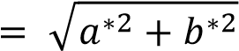

𝐵𝐼 = 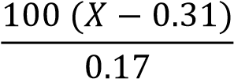

where:

𝑎∗ +1.75 𝐿∗
𝑋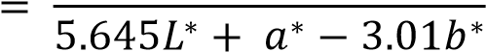

2.8. Sensory analysis

The profile method was used to determine sensory properties of the cookies. 20 individuals evaluated the cookies. All the panelists had completed sensory analysis classes and passed the sweet and salty threshold test and were trained for profiling method. The sensory analysis was conducted in laboratory conditions. Each person was given one cookie of each variant and an evaluation card with instructions concerning the evaluation procedure. 10 cm unscaled line was used to rate each of the discriminants: typical odour (typical for wholegrain cookies), algae odour, browning uniformity, dark color, hardness, crispiness, taste (typical for wholegrain cookies), algae taste and overall sensory quality (all sensory properties which influence acceptability and quality). Intensity of the discriminants was increasing from left to right side of the line. Samples were presented in the same containers in randomized order and labeled with three digit random numbers. First, the evaluators examined odour and appearance of the cookies. After the first bite the hardness of the product was evaluated. Hardness is the first experienced sensation and then crispness, which is noticeable 10 seconds after the first bite. Crispness is a sensation of brittleness in the mouth, when the teeth crack the product during mastication, with multiple fractures at low force loads. After chewing, soaking the bite in saliva and swallowing, when all the taste substances reached taste buds, the panelists evaluated the taste of cookies. In the end, the evaluators rated the overall quality of products, taking into account all the discriminants (LAGUNA et al., 2013; ONACIK-GÜR et al., 2015).

2.9. Statistical analysis

Statistical analysis was performed by means of a computer program Statistica 12.0 (StatSoft, USA). The data was subjected to ANOVA including post hoc comparison Tukey’s test, at the probability level α = 0.05 to determine significant differences. Moreover, Person’s correlation was carried out for the results, p-value ≤ 0.05.

3. RESULTS AND DISCUSSIONS

3.1. Physical properties and texture of cookie dough and cookies

Addition of spirulina did not have significant effect (Table 1) on cookie dough and cookie density. No significant differences were observed in geometry of cookies, either. However, it was found that addition of microalgae powder decreased the spread ratio of cookies. Other researchers found that addition of fiber may have such impact on spread ratio of cookies (GUPTA et al., 2011).

Table 1. Physical properties of cookie dough and cookies.

Spirulina addition  [%] | Cookie dough density [g/cm³] | Diameter [mm] | Thickness [mm] | Cookie density  [g/cm³] | Spread  ratio [D/T] | Water content [%]
0 | 1.08±0.04ª | 58.56±1.43ª | 8.02±0.28ª | 0.85±0.01ª | 7.31±0.12^{b} | 4.16±0.05 ^{b}
1 | 1.12±0.09ª | 58.86±1.06ª | 8.33±0.27ª | 0.91±0.01ª | 7.05±0.16ª | 4.05±0.05 ^{b}
2 | 1.11±0.09ª | 58.70±1.00ª | 8.31±0.21ª | 0.94±0.05ª | 7.06±0.15ª | 3.83±0.09 ª
3 | 1.11±0.09ª | 58.64±1.18ª | 8.27±0.36ª | 0.93±0.11ª | 7.08±0.14ª | 3.79±0.06 ª

*a, b, c - describes homogenous groups.
p-value ≤ 0.05.

However, the addition of microalgae decreased the moisture content of the baked product (Table 1). Decreasing water content in the product can be related to a partial reduction of flour, which was replaced by spirulina. Wholegrain flours used to produce these cookies, since they were rich in fiber, which increased the water absorption (SOBCZYK, 2012).
Addition of spirulina did not significantly affect the firmness and adhesive force of cookie dough. Even when the enrichment level of microalgae powder increased, the dough had

the same textural parameters (Fig. 1).
a
a
a
a
a
ab
a
a
-0
,6
-0
,4
-0
,2

0
0
,2
0
,4
0
,6
,8
0
1

0
%
1
%
2
%
3
%
S
pirulina content
firmness [N]
adhesive force [N]

Fig. 1. Textural properties of cookie dough.
* a, b - describes homogenous groups, p-value ≤ 0.05.

However, the addition of algae decreased the hardness of cookies. Statistically significant differences were not observed among additions at the levels of 1, 2 and 3% of spirulina. However, a tendency was found showing that the hardness of cookies decreased in line with microalgae powder content (Fig. 2). GOUVEIA et al. (2007) arrived at opposite conclusions in their study, where the hardness of cookies was increasing with the microalgae level enrichment. In our study, microalgae powder was added to the recipe as a flour replacer, which is rich in fiber and absorbs high quantities of water, while spirulina is rich in protein (60%) (PELIZER et al., 2015). A partial replacement of flour caused a decrease in fiber content, which significantly changed the water absorption. As a consequence, the structure was less compact and the hardness decreased (GOUVEIA et al., 2008; SUDHA et al., 2007). SHYU and SUNG (2010) observed a decrease in hardness with increasing addition of γ-polyglutamic acid obtained from Bacillus spp.
Addition of spirulina did not change significantly the fracturability of cookies on the first day after baking. However, the difference was visible during storage. In the 6th and 9th weeks, it was found that the fracturability of cookies decreased with spirulina enrichment level (Fig. 3).
Texture of cookies during the storage did not change significantly. Products with 1% addition of spirulina had a slightly lower hardness in the 9th week. Nonetheless, it was found that fracturability of cookies decreased at the time of storage.

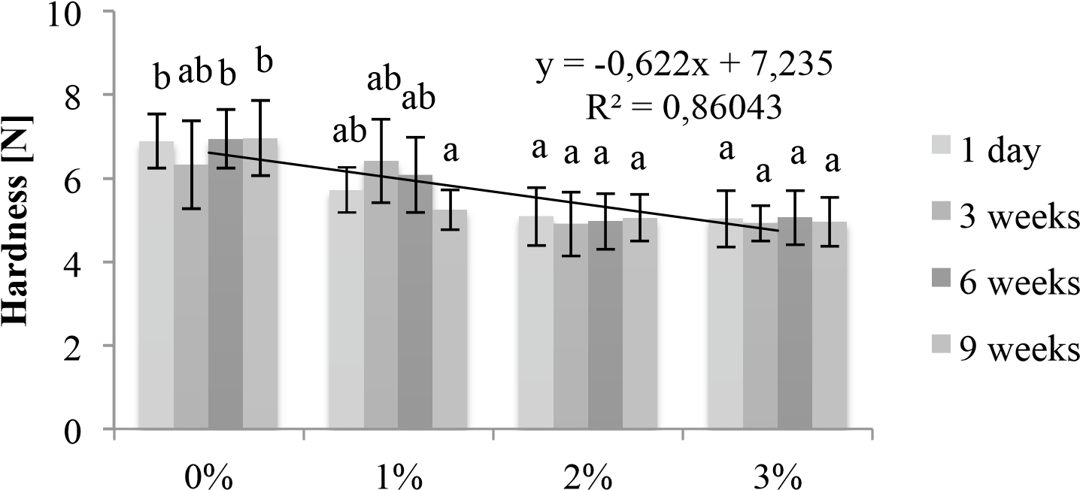

Fig. 2. Hardness of cookies.
- a, b - describes homogenous groups, p-value ≤ 0.05.

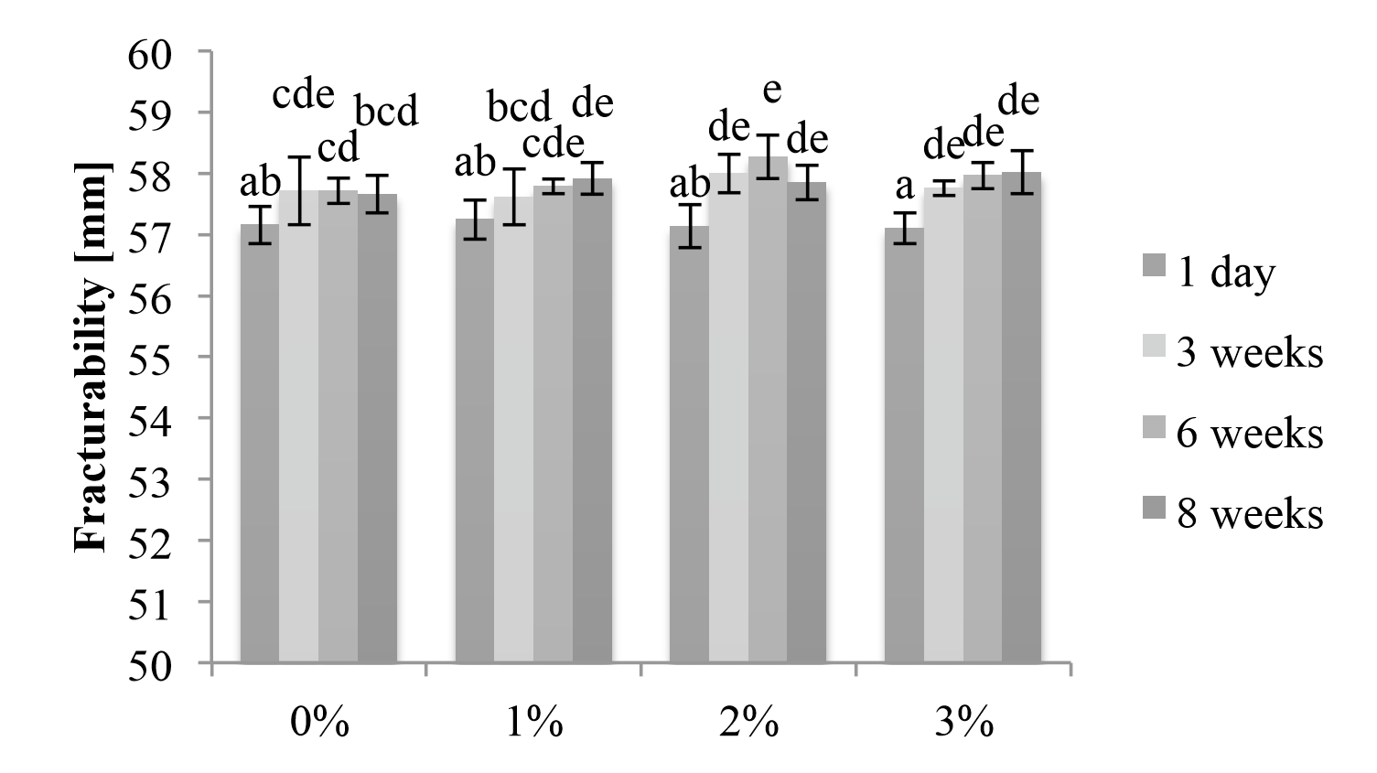

Fig. 3. Fracturability of cookies.
- a, b, c, d, e - describes homogenous groups, p-value ≤ 0.05.

3.2. Color of cookies and cookie dough

Color parameters of the cookie dough and cookies changed statistically significantly depending on the amount of spirulina addition. Parameters L* (white/black), a* (red/green) and b* (yellow/blue) were decreasing for cookie dough and cookies with increasing content of microalgae powder. It shows that baked products and dough were becoming more green-blue with increasing content of spirulina in the recipe. Similar results were obtained by GOUVEIA et al. (2008) who added microalgae Isochrysis galbana to cookies.
∆E value increased in products before and after baking by adding higher amounts of spirulina. Chroma indicates the saturation – intensity of color (BAL et al., 2011) and the highest values were obtained for the control sample (without a spirulina addition) despite a strong green color of samples with microalgae addition. The sample of cookie dough with the lowest addition of spirulina (1%) has the lowest color saturation value, which increased with larger quantities of this additive. Color saturation results for the baked cookies were the reverse, as chroma decreased with increasing addition of spirulina.
Browning index (BI) indicates the purity of brown color, which is particularly important when products are dried (BAL et al., 2011) or, in the case of cookies, baked. This index decreased with the addition of spirulina and rose after the same samples were baked (Table 2).

Table 2. Color parameters of cookie dough and cookies.

Spirulina addition |  | L* | Color parameters  a* | b* | ΔE | Chroma | BI
Cookie  dough | 0%  1%  2%  3%  0%  1%  2% | 49.18±2.40 ^{c}  39.80±2.20 ^{b}  37.34±0.94 ^{ab}  36.58±0.73 ª  61.89±2.77 ^{c}  50.61±1.02 ^{b}  45.89±1.68 ª | 4.97±0.12 ^{c}  -0.39±0.66 ^{b} -0.96±0.49 ª  -1.84±0.26 ª  5.46±0.31 ^{c}  0.83±0.71 ^{b}  -0.35±0.44 ª | 9.45±0.72 ^{c}  0.48±0.28 ª  -1.70±0.49 ^{b}  -2.51±0.64 ^{b}  20.45±1.00^{d}  14.01±1.58 ^{c}  9.62±1.07 ^{b} | 0  14.04  17.31  18.66  0  13.79  20.18 | 10.68  0.62  1.95  3.11  21.17  14.03  9.63 | 28.35  0.48  -6.15  -10.01  45.83  32.85  22.37
Cookie

 | 3% | 42.96±1.59 ª | -0.44±0.70 ª | 6.75±0.59 ª | 24.10 | 6.76 | 15.91

*a, b, c - describes homogenous groups.
p-value ≤ 0.05.

3.3. Sensory analysis

Microalgae powder had a positive impact on uniformity of browning. Color of the cookies became darker with the increasing addition of algae, which was confirmed in instrumental analysis. Cookies with the highest 3% addition of spirulina were the hardest, while the control sample 0% (without addition) and the one with lowest addition of spirulina (1%) were the softest. The results were not confirmed with the instrumental texture analysis, where the hardness of cookies decreased with the content of microalgae powder. Hardness in sensory analysis could be affected by the density and thickness of cookies. In the 3-point blend test, a cookie breaks when first touched by a probe, while biting teeth are going through the whole cookie. That is why in some studies it was found that hardness measured instrumentally is more correlated to crunchiness or crispiness than hardness of the first bite (KIM et al., 2011). Another explanation for the difference of sensory hardness perception in relation to instrumental hardness can be due to the fact that an instrumental test always measures the force in the middle of the cookie, while the first bite is usually taken from a side. In the case of crispness, no influence of spirulina addition was observed (Table 3). Fracturability, which is measured instrumentally, should by definition be comparable with crispness and no significant differences were found for both of them. The intensity of sensing the taste and odour of algae between cookies with 2% and 3% of spirulina was similar.

Table 3. Sensory analysis of cookies with spirulina.

Spirulina powder content | Typical odour | Algae odour | Browning uniformity | Dark color | Hardness | Crispness | Typical taste | Algae taste |  | Overall sensory quality
0% | 7.08±2.05 ^{b} | 0 ª | 6.38±2.82 ª | 3.46±0.82ª | 4.09±2.54ª | 7.35±1.57ª | 6.64±2.32ª | 0 ª |  | 7.24±1.66ª
1% | 5.62±2.2 ^{ab} | 2.64±1.80 ^{ab} | 6.22±2.60 ª | 4.79±1.08ª | 4.15±1.67ª | 6.73±1.90ª | 4.86±1.44ª | 4.11±1.66^{b} |  | 5.64±2.21^{ab}
2% | 3.88±1.95 ª | 4.55±1.14 ^{b} | 7.25±1.68 ª | 7.10±1.68^{b} | 4.75±1.82ª | 7.72±1.15ª | 3.42±1.32^{ab} | 6.35±1.02^{b} |  | 5.48±2.38^{ab}
3% | 3.50±2.25 ª | 4.88±1.70 ^{b} | 7.62±1.54 ª | 7.62±1.54^{c} | 5.8±2.40ª | 6.57±1.60ª | 3.09±1.97^{b} | 6.56±1.25^{b} |  | 5.10±1.99^{b}

*a, b, c - describes homogenous groups, p-value ≤ 0.05.

Table 4. Correlation of variables – properties of cookie dough and cookies, p-value ≤ 0.05.

 | spirulina | Dd | Dc | h | d | m | Fd | Fc | ΔEc | chroma c | BI c | Q | hard
Dd | 0,59 | 1,00 | 0,84 | 0,98 | 0,85 | -0,56 | 0,73 | -0,96 | 0,78 | -0,73 | -0,68 | -0,89 | 0,31
Dc | 0,87 | 0,84 | 1,00 | 0,91 | 0,46 | -0,90 | 0,90 | -0,95 | 0,96 | -0,95 | -0,93 | -0,96 | 0,63
h | 0,66 | 0,98 | 0,91 | 1,00 | 0,79 | -0,66 | 0,77 | -0,99 | 0,84 | -0,79 | -0,75 | -0,92 | 0,35
d | 0,08 | 0,85 | 0,46 | 0,79 | 1,00 | -0,05 | 0,26 | -0,69 | 0,33 | -0,25 | -0,19 | -0,51 | -0,23
m | -0,97 | -0,56 | -0,90 | -0,66 | -0,05 | 1,00 | -0,93 | 0,76 | -0,95 | 0,97 | 0,98 | 0,87 | -0,87
Fd | 0,98 | 0,73 | 0,90 | 0,77 | 0,26 | -0,93 | 1,00 | -0,86 | 0,98 | -0,99 | -0,99 | -0,96 | 0,87
Fc | -0,87 | -0,96 | -0,95 | -0,99 | -0,69 | 0,76 | -0,86 | 1,00 | -0,91 | 0,87 | 0,84 | 0,96 | -0,49
ΔEc | 0,96 | 0,78 | 0,96 | 0,84 | 0,33 | -0,95 | 0,98 | -0,91 | 1,00 | -0,99 | -0,99 | -0,98 | 0,79
chroma c | -0,98 | -0,73 | -0,95 | -0,79 | -0,25 | 0,97 | -0,99 | 0,87 | -0,99 | 1,00 | 0,99 | 0,96 | -0,84
BI c | -0,99 | -0,68 | -0,93 | -0,75 | -0,19 | 0,98 | -0,99 | 0,84 | -0,99 | 0,99 | 1,00 | 0,94 | -0,87
Q | -0,90 | -0,89 | -0,96 | -0,92 | -0,51 | 0,87 | -0,96 | 0,96 | -0,98 | 0,96 | 0,94 | 1,00 | -0,70
hard | 0,93 | 0,31 | 0,62 | 0,35 | -0,22 | -0,87 | 0,87 | -0,74 | 0,79 | -0,84 | -0,87 | -0,70 | 1,00
crisp | -0,32 | -0,40 | -0,10 | -0,26 | -0,30 | 0,09 | -0,42 | 0,29 | -0,29 | 0,28 | 0,26 | 0,39 | -0,39

Legend: Dd – density of cookie dough, Dc – density of cookies, h – height of cookies, d – diameter of cookies, m – moisture content, Fd – hardness of cookie dough, fr – fracturability of cookies, Fc – hardness of cookies (measured instrumentally), ∆Ec – total color difference of cookies, chroma c – color saturation of cookies, BI c – browning index of cookies, Q – overall sensory quality, hard – hardness (sensory analysis), crisp – crispness.

Ital. J. Food Sci., vol. 30, 2018 - 9

Spirulina addition has adversely influenced sensory quality of cookies. It caused a decrease in typical aroma, typical taste and overall sensory quality – acceptability. In the study by SHARMA and DUNKWAL (2012), the acceptability of biscuits with addition of 10% of spirulina powder did not result in low acceptability. Scores obtained for the control biscuits and spirulina based biscuits were similar. In comparison, the microalgae content was much higher than in the study presented in this paper. High overall acceptability in the study conducted by SHARMA and DUNKWAL (2012) can be due to the fact that eating habits and flavor preferences are different in India and in Poland.

3.4. Correlation between qualitative parameters of cookie dough and cookies

It was observed that addition of spirulina had an effect on the analyzed parameters of cookies and cookie dough. Only crispness, cookie geometry and density of cookie dough were weakly correlated with the amount of microalgae powder addition. Statistical analysis indicated a statistically significant correlation between hardness measured by texture analyzer, color parameters and overall sensory quality (p<0,05). Color was strongly and significantly dependent on the spirulina content in the recipe. Based on the statistical analysis, it can be assumed that crispness and fracturability of cookies with spirulina did not depend significantly on any of the analyzed variables (Table 4). The variables describing properties of cookie dough had strongly correlated with those describing the baked product. This may indicate that by knowing properties of the cookie dough before baking, we can anticipate features of the final product. Hardness of cookies measured with texture analyzer was correlated with spirulina content, which was also confirmed by linear regression (Fig. 2).

4. CONCLUSIONS

Spirulina has influence on most physical and sensory properties of cookies. Its even minor addition had strong impact on change of color to green of the cookie dough and baked products. Addition of microalgae caused a decrease in moisture content and hardness measured by texture analyzer. It was observed that the color and hardness of products had an impact on the overall sensory quality. More brown color and less green improved acceptance of a product.
Because of increasing consumers’ interest in novel food ingredients such as microalgae, production of cookies with spirulina addition may be a forward-looking development. Due to high content of bioactive ingredients and low sensory acceptability 1% addition of spirulina powder seems to be optimum. Unfortunately, larger quantities of spirulina caused significant changes in some parameters affecting quality of cookies.

REFERENCES

Bajerska J., Mildner-Szkuldarz S., Górnaś P. and Seglina D. 2016. The effects of muffins enriched with sour cherry pomace on acceptability, glycemic response, satiety and energy intake: a randomized crossover trial. J. Sci. Food Agr. 96(7):2486-2493.

Bal L.M., Kar A., Satya S. and Naik S.N. 2011. Kinetics of colour change of bamboo shoot slices during microwave drying. Int. J. Food Sci. Tech. 46:827-833.

Białek M. and Rutkowska J. 2015. The importance of linolenic acid in the prevention and treatment. Postępy Hig Med Dosw 69:892-904

Cheng Y.F. and Bhat R. 2016. Functional, physicochemical and sensory properties of novel cookies produced by utilized jering (Pithecellobium jiringa Jack.) legume flour. Food Biosci. 14:54-61.

Demirkesen I. 2016. Formulation of chestnut cookies and their rheological and quality characteristics. J. Food Qual. 39 (3):264-273

Figuera F.S., Crizel T.M., Silva C.R. and Salas-Mellado M.M., 2011. Elaboration of gluten-free bread enrichment with the microalgae Spirulina platensis, Braz J. Food Technol. 14(4):308-316.

Gouveia L., Coutinho C., Mendonça E., Batista A.P., Sousa I., Bandarra N.M. and Raymundo A. 2008. Functional biscuits with PUFA-ω3 from Isochrysis galbana. J. Sci. Food Agr. 88:891-896.

Gupta M., Bawa A.S. and Abu-Ghannam N. 2011. Effect of barley flour and freeze-thaw cycles on textural nutritional and functional properties of cookies. FBP 89:520-527.

Habib B.A.M., Mashuda P. and Huntington T.C. 2008. A review on culture, Production and use of spirulina as food for humans and feeds for domestic animals and fish. FAO of the UN. Retrieved November 20.

Kay R.A. and Barton L.L. 1991. Microalgae as food and supplement. Crit. Rev. Food Sci. Nutr. 30(6):555-573.

Kim E. H-J., Corrigan V.K., Wilson A.J., Waters I.R., Hedderley D.I. and Morgenstern M.P. 2011. Fundamental fracture properties associated with sensory hardness of brittle solid foods. J. Texture Studies

Kozłowska M., Żbikowska A., Gruczynska E., Została, K. and Połtorak A. 2014. Effects of spice extracts on lipid fraction oxidative stability of cookies investigated by DSC. J. Therm. Anal. Calorim. 118: 1697-1705.

Kumoro A.C., Johnny D. and Alfilovita D. 2016. Incorporation of microalgae and seaweed in instant fried wheat noodles manufacturing: nutritional and culinary properties study. Int. Food Res. 23(2):715-722.

Kurd F. and Samavati V. 2015. Water soluble polysaccharides from Spirulina plantesis: Extraction and in vitro anti-cancer activity. Int. J. Biomed. Macromol. 74:498-506.

Laguna L., Varela P., Salvador A. and Fiszman S. 2013. A new sensory tool to analyze the oral trajectory of biscuits with different fat and fiber contents. Food Res. Int. 51:544-553.

Liang S., Liu X., Chen F. and Chen Z. 2004. Current microalgal health food R&D activities in China, In: Asian Pacific Phycology in the 21st Century: Prospects and Challenges. Hydrobiologia 512:45-48.

Mildner-Szkudlarz S., Zawirska-Wojtasiak R., Obuchowski W. and Gośliński M. 2009. Evaluation of antioxidant activity of green tea extract and its effect on biscuits lipid fraction oxidative stability. J Food Sci. 74:362-370.

Onacik-Gür S., Żbikowska A. and Jaroszewska A. 2015. Effect of high-oleic sunflower oil and other prohealth ingredients on physical and sensory properties of biscuits. CYTA – Journal of Food 13(4):621-628.

Pelizer L.H., De Carvalho J.C.M. and Moraes I.O. 2015. Protein production by Arthrospira (spirulina) platensis in solid state cultivation using sugarcane bagasse as support. Biotechnology Reports 5:70-76.

Rehmati N.F. and Tehrani M.M. 2014. Influence of different emulsifiers on characteristics of eggless cake containing soy milk: Modeling of physical and sensory properties by mixture experimental design. JFST 51(9):1697-1710.

Sharma V. and Dunkwal V. 2012. Development of Spirulina based “biscuits”: a potential method of value addition, Ethno Med 6(1):31-34.

Shyu Y.S. and Sung W.C. 2010. Improving the emulsion stability of sponge cake by the addition of γpolyglutamic acid. J. Mar. Sci. Tech.–Taiw. 18(6):895-900.

Sobczyk M. 2012. Wpływ dodatku płatków jęczmiennych na jakość ciasta i pieczywa pszennego. ZPPNR 570:87-96.

Sudha M.L., Vetrimani, R. and Leelavathi K. 2007. Influence of fiber from different cereals on the rheological characteristics of wheat flour dough and on biscuit quality. Food Chem. 100 (4):1365-1370.

Tang, G. and Suter P.A. 2011. Vitamin A, Nutrition, and health value of Algae: Spirulina, Chlorella, and Dunaliella. J. Pharm. Nutr. Sci. 1:111-118.

Paper Received December 20, 2016 Accepted March 20, 2017

